A Project Report

On

Alzheimer’s Disease Detection

USING DEPP LEARNING APPROACH

SUBMITTED IN PARTIAL FULFILLMENT

OF THE REQUIREMENTS

FOR B.TECH PROJECT

By

Ahmar Hasan Arish (2006110)

Ankit Kumar (2006115)

Vishal Anand (2006181)

Under The Supervision Of

DR. KRISHAN KUMAR SHETHI



DEPARTMENT OF COMPUTER SCIENCE AND ENGINEERING

NATIONAL INSTITUTE OF TECHNOLOGY, PATNA (JUNE 2023)

**Certificate**

NATIONAL INSTITUTE OF TECHNOLOGY PATNA

Department of Computer Science and Engineering



This is to certify that Mr. Ahmar Hasan Arish (Roll No. 2006110), Mr. Ankit Kumar (Roll no. 2006115) and Vishal Anand (Roll No. 2006181) are registered candidates for B.Tech program under department of **Computer Science and Engineering** of **National Institute of Technology Patna**.

I hereby certify that they have completed all other requirements for submission of the minor project and recommend for the acceptance of a minor project entitled, “**Alzheimer’s Disease Detection Using Deep Learning**” in the partial fulfillment of the requirements for the award of B.Tech degree.

**Dr. Krishan Kumar Sethi**

**Prof. Maheshwari Prasad Singh**

Head of Department, CSE

Project Supervisor

Professor Department of CSE

May-2023

**Declaration and Copyright Transfer**

We, Ahmar Hasan Arish (Roll No. 2006110) Ankit Kumar (Roll no. 2006115) and Vishal Anand (Roll No.2006116) registered candidates for B.Tech Program under department of **Computer Science and Engineering** of **National Institute of Technology Patna**, declare that this is our own original work and does not contain material for which the copyright belongs to a third party and that it has not been presented and will not be present to any other University/ Institute for a similar or any other degree award.

We further confirm that for all third-party copyright material in our project (Including any electronic attachment), we have “blanked out” third party material from the copies of the thesis/dissertation/book/articles etc; fully referenced the deleted materials and where possible, provided links (url) to electronic source of the material.

We hereby transfer exclusive copyright for this Project to NIT Patna. The following rights are reserved by the author:

1. The right to use, free of charge, all or part of this Project in future work of their own, such as books and lectures, giving reference to the original place of publication and copyright holding.
2. The right to reproduce the project for their own purpose provided the copies are not offered for sale.

Signature of the candidates:

1. Ahmar Hasan Arish 2. Ankit Kumar 3. Vishal Anand

Date:…………

**COPYRIGHT ©[2023] by NIT Patna, All rights reserved.**

*No part of this publication may be reproduced, distributed or transmitted in any form or by any means, including photocopying, recording, or other electronic or mechanical methods, without the prior written permission, expect in the case of brief quotations embodied in critical scholarly reviews and certain other non-commercial uses with an acknowledgment/reference permitted by the copyright law.*

**Acknowledgement**

It gives us immense pleasure to express our regards and profound gratitude to our project supervisor **Dr. Krishan Kumar Sethi (Department of Computer Science & Engineering, National Institute of Technology Patna)** for her expert guidance and unflinching support throughout our project work. We are highly indebted to him for his painstaking attention towards our project and the innumerable number of improvements suggested by him, which helped us to shape our project to perfection. His completeness and endurance in this regard is unquestionable.

We express sincere thanks to **Dr M.P Singh (H.O.D. Department of Computer Science and Engineering, National Institute of Technology Patna)** for their co-operation and providing all required facilities.

We thank our parents, and all the faculty members of Department of Computer Science & Engineering for their constant support and encouragement.

|  |  |
| --- | --- |
| **Ahmar Hasan Arish** | 2006110 |
| **Ankit Kumar** | 2006115 |
| **Vishal Anand** | 2006181 |

**ABSTRACT**

Numerous approaches and practical for detecting Alzheimer’s disease have been developed over time. Understanding the scanned images of the human brain is the initial stage in this procedure. This explain the extent to which the brain has been damaged.

To extract usable information from an image, Image Processing employs a number of algorithms. Each algorithm generates output in its own way. As a result, the efficiency of each method differs. A few image segmentation algorithms are employed to segment the photos in order to obtain the needed information, and ground truth is used to validate the results.

The purpose of this project is to develop a deep learning model that can accurately detect Alzheimer's disease from MRI scans of the brain. Three different types of deep learning models were utilized, including convolutional neural networks (CNN), recurrent neural networks (RNN), and DenseNet and Inception models. A dataset containing MRI scans from both healthy individuals and individuals diagnosed with Alzheimer's disease was used to train and validate the models. The models were evaluated based on their accuracy, precision, recall, and F1-score. Results show that the Inception model outperformed the other models, achieving an accuracy of 92.27% while the traditional CNN model achieved a respectable frequency of 75.02%. These findings demonstrate the potential of deep learning models in accurately diagnosing Alzheimer's disease from MRI scans and can help in early diagnosis and treatment of the disease.

**Table of Contents**

* Introduction
* Literature Survey
* Methodology
* Implementation
* Results And Analysis
* Deployment of Model
* Conclusion And Future Scope
* References

1. **Introduction**

Alzheimer’s disease is a brain disorder that affects people of all ages. At first, the symptoms are modest, but as time passes, they get more severe. It was named after Dr. Alois Alzheimer, who described the illness for the first time in 1906 Trusted Source. Alzheimer’s disease is a mild and progressive condition, meaning that the symptoms get severe over time. Memory loss is a flagship, and this will be one of the first symptoms to hit. The symptoms appear gradually, over months or years. If they being developed over long period, a person may require medical attention. One of the most affected part due to this Alzheimer’s is Corpus Callosum which is responsible for communication in the brain.



Figure 1.1 An Alzheimer disease infected people

* 1. **Statistics:**

Alzheimer’s disease affects over 5.5 million people in the US aged over 60. Eighty percent of those surveyed are over 75. Alzheimer’s disease is expected to effect 60 to 70 percent of the approximately fifty million people globally who already suffered with dementia.

* 1. **Symptoms:**

1. Causes Anterograde Amnesia

2. Reduces speaking ability

3. Infects the frontal lobe of the brain

4. Causes Mood imbalance

5. Minimize Decision making ability.

* 1. **Background:**

Human brain consists of a main part called Neuron. Neuron which transfers information to body parts. There are nearly over 80 billion of Neurons in a human brain connect with each other as in picture. The linked part two neurons is called a Synapse, highlighted by circling in the below picture. The Synapse is the location where neurotransmitters such as glutamine are released and transmission of data or information takes place in between the neurons. In addition to neurotransmitters, it also releases a small peptide called beta amyloid. Normally amyloid beta is cleared away by microglia, the cells of our brain. Due to hypertension release of amyloid beta increase to much of increase and less clearance of amyloid beta, they accumulate each other form sticky aggregate called amyloid plaques. These amyloid plaques block information transfer from one neuron to neuron, which the main reason for Alzheimer’s disease. Due to rapid release of amyloid plaques, microglia set off hyper activated and emits chemical that ruin synapse. A necessary neuron called “tau” becomes hyper phosphated twisted themselves in order to form a structure named tangles, which squash the neurons from inside.

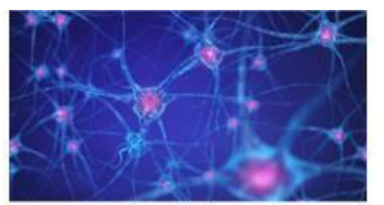 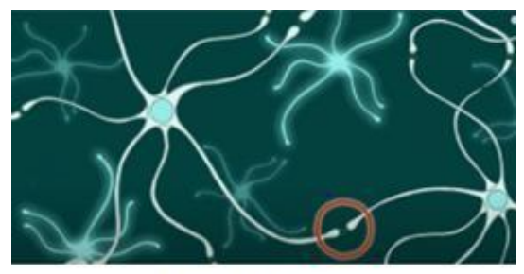

Figure 1.2 Neurons Figure 1.3 Synapse

* 1. **Prevention:**

At Present, there is no specific drug or medicine for healing AD. In general, the lower levels of acetylcholine in the brain leads to the initiation of AD. Cholinergic drugs are used to prevent AD. All these precautions measured are pertinent theoretically, but no practical way of curing AD.

* 1. **Motivation:**

With the current technological advancements in the medical sector, it has become possible to track and cure diseases. Even after this, there are certain diseases which are difficult to track and cure, one such disease is Alzheimer’s. There are various organizations and research communities worldwide that are working hard to find a permanent cure for AD. This requires a lot of man hours to get a significant result.

* 1. **Objective of Work:**

This can be possible by Image Processing. The person’s brain who are affected by AD are analyzed and, thereby generalizing a pattern in which a person is affected by AD. By observing the structure of the brain, several major differences can be found between a normal brain, Mild cognitive impairment (MCI) brain and AD brain. These differences form a way for the identification of AD at its early stages, which can be done by segmenting the affected part of the brain. It is not possible to cut a person’s brain to find whether he has AD or not and can be only done through Image Processing. This helps in early detection of AD, which improves prevention process, since curing may not be possible. It is miserable for anyone to be affected by AD, but it has become one of the most common and unrecognized diseases, using several image processing techniques at least we can extend the time taken for going from MCI to AD.

Here we have chosen Inception model and DesnseNet model to process the MRI-Scan of human’s brain and detect whether it’s demented to what extent it’s demented.

1. **Literature Survey**

**S. Al-Shoukry, T. H. Rassem and N. M. Makbol, "Alzheimer’s Diseases Detection by Using Deep Learning Algorithms: A Mini-Review," in IEEE Access, vol. 8, pp. 77131-77141, 2020, doi: 10.1109/ACCESS.2020.2989396.**

This paper uses CNN to predict AD class.

84% accuracy was obtained when CNNs were used to segregate the progressive MCI patients from the stable MCI patients. Payan and Montana [75] developed an algorithm that used MRI scans to evaluate the condition of a particular patient. They used a total of 2,265 cases, and they selected the ADNI dataset for their work.[1]

**Previtali F, Bertolazzi P, Felici G, Weitschek E. A novel method and software for automatically classifying Alzheimer's disease patients by magnetic resonance imaging analysis. Comput Methods Programs Biomed. 2017 May;143:89-95. doi: 10.1016/j.cmpb.2017.03.006. Epub 2017 Mar 4. PMID: 28391822.**

**Publisher: Pub**

They report the comparison with recent state-of-the-art approaches on two established medical data sets (OASIS).They obtained a classification accuracy, sensitivity and specificity of 77% and specificity of 79% when dealing with four classes.[2]

1. **Methodology**

We have used following models to label a MRI image class as demented or not:

1. CNN
2. RNN
3. Inception-v3
4. DenseNet-121
   1. **Tools Used:**

Programming language- python

Image processing and machine learning libraries- Keras, Tensorflow

* 1. **Data Collection:**

The ADNI dataset is a collection of data obtained from participants in the Alzheimer's Disease Neuroimaging Initiative (ADNI) study launched in 2004 that aims to improve our understanding of Alzheimer's disease by

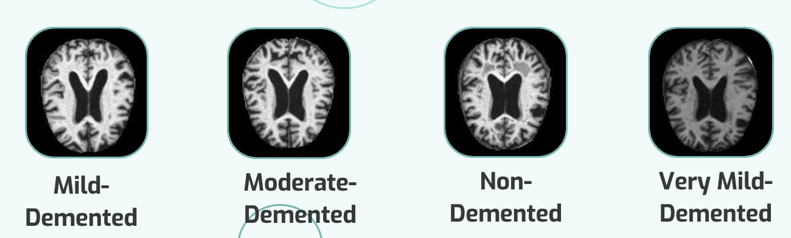

Figure 3.1 A sample dataset

identifying biomarkers and developing better methods of diagnosis, treatment, and prevention.

Dataset consists of two files - Training and Testing both containing a total of around ~5000 images each segregated into the severity of Alzheimer’s classes.

* 1. **Data Pre-Processing:**
     1. **Augmentation:**

Performed Image Data Augmentation on given MRI data. It is a technique that creates new images from the existing ones.

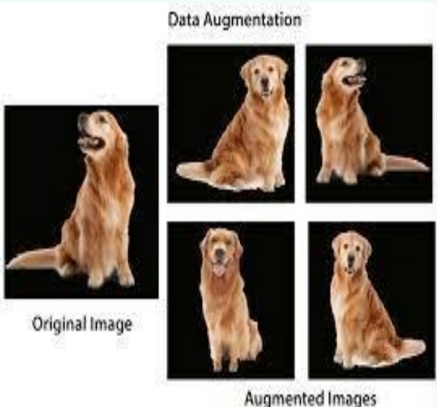

Figure3.2 augmented images

To do that we make some small changes to them such as adjusting the brightness of the image, or rotating the image, or shifting the subject in the image horizontally or vertically. Image augmentation techniques allow us to artificially increase the size of our training set, thereby providing much more data to our model for training. This allows we to improve the accuracy of our model enhancing the ability of our model to recognize new variants of our training data.

* + 1. **Resize:**

The input images are resized to 224x224 pixels before being fed into the model. Resizing the images to the fixed size ensures that input data is consistent and allow the model to process the images more efficiently.

* + 1. Labels are **one-hot encoded.**
    2. **Batch Size:**

Batch size used is of 32, it indicates that the generator will generate batches of 32 samples each. During training, the model will be updated after each batch of data is fed into the model.

1. **Implementation**
   1. **Using CNN**

In our Alzheimer's disease detection model, we have used a convolutional neural network (CNN) architecture. A CNN is a type of deep learning neural network that is commonly used for image recognition and classification tasks. The key advantage of using CNNs over other traditional neural network architectures is their ability to automatically learn relevant features from images through the use of convolutional layers.

The CNN architecture consists of several layers, including convolutional layers, pooling layers, and fully connected layers. The convolutional layers perform feature extraction from the input images by applying a set of filters to the image. Each filter slides over the entire image, computing the dot product between the filter weights and the pixel values at each location. This process generates a feature map for each filter, highlighting specific features such as edges, corners, and shapes present in the image.

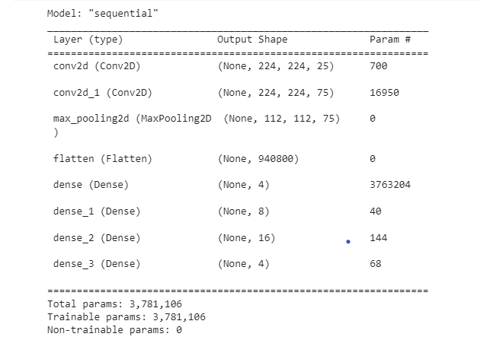

Figure 4.1 CNN model summary

**The pooling layers** reduce the size of the feature maps generated by the convolutional layers by performing a max or average operation over a small window. This reduces the number of parameters in the network and helps prevent overfitting.

**The fully connected layers** perform classification by taking the flattened output from the previous layer and mapping it to the output classes. The weights in these layers are learned through the process of backpropagation during training.

In our Alzheimer's disease detection model, we have used **dropout layers** to prevent overfitting and improve the generalization performance of the model. By randomly dropping out neurons in the fully connected layers, the model is forced to learn more robust features and prevent it from overfitting to the training data.

We have used multiple convolutional and pooling layers to learn complex features from the MRI scans of the brain. The outputs from these layers were then passed through fully connected layers for classification.

Thus, CNNs are a powerful tool for image classification and have been shown to be effective for diagnosing Alzheimer's disease from MRI scans of the brain.

* 1. **Using RNN**

In addition to the convolutional neural network (CNN) architecture, you have also used a recurrent neural network (RNN) in your Alzheimer's disease detection model. RNNs are a type of neural network that are commonly used for sequence modeling tasks such as speech recognition, language translation, and text generation.

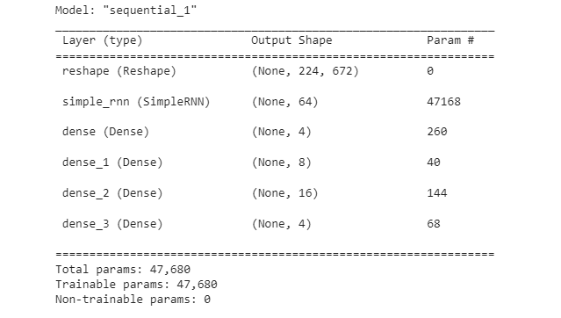

Figure 4.2 RNN model summary

Unlike traditional feedforward neural networks, RNNs have loops in their architecture that allow them to process sequences of inputs one element at a time, while maintaining an internal state that captures information about the sequence seen so far. This makes RNNs well-suited for modeling sequences of variable length, such as time-series data, audio signals, and text.

The key component of the RNN architecture is the recurrent layer, which maintains a hidden state that is updated at each time step based on the current input and the previous hidden state. The hidden state serves as a memory that allows the network to capture information about the sequence seen so far and make predictions based on that information.

In our Alzheimer's disease detection model, we have used an RNN architecture with one or more recurrent layers to model the temporal dependencies present in the MRI scans of the brain. By processing the MRI scans as a sequence of images, the RNN can capture temporal changes and patterns that may be indicative of Alzheimer's disease.

* 1. **Using DenseNet-121**

DenseNet-121 is a type of deep convolutional neural network (CNN) that has several advantages over traditional CNNs and recurrent neural networks (RNNs).

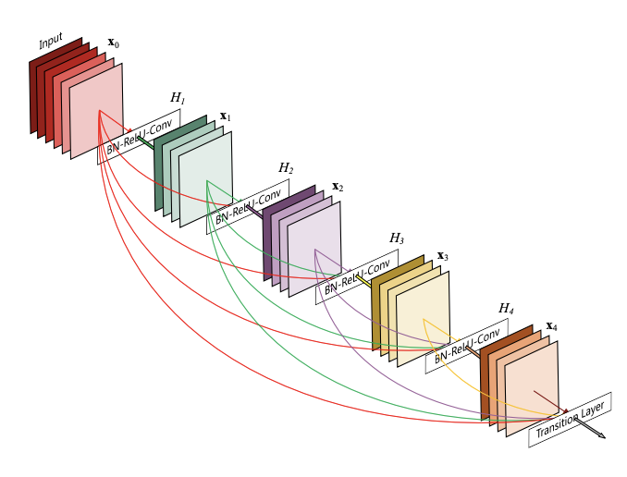

Figure 4.3: A DenseNet Model

The key feature of DenseNet-121 is its use of dense blocks, which are made up of multiple layers that are connected to all subsequent layers in the block. This allows each layer to have access to the feature maps generated by all previous layers in the block, leading to more efficient use of parameters and improved feature propagation through the network.

The DenseNet-121 architecture consists of several blocks of dense layers, followed by transition layers that reduce the spatial dimensions of the feature maps. The dense layers use a combination of convolutional, batch normalization, and activation functions to learn complex features from the input images. The transition layers use pooling or convolution operations to reduce the spatial dimensions of the feature maps, while preserving the depth of the feature maps.

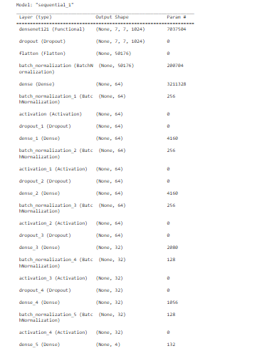

Figure 4.4: Summary of DenseNet Model

In our Alzheimer's disease detection model, we have used the DenseNet-121 architecture to learn complex features from the MRI scans of the brain. By leveraging the dense connectivity between layers, the model can learn more efficient representations of the input data and make more accurate predictions. DenseNet-121 has been shown to be effective for image classification tasks, and has also been applied successfully to medical imaging tasks such as diagnosing Alzheimer's disease from MRI scans of the brain.

* 1. **Using Inception-v3**

In traditional CNNs, each convolutional layer typically has a fixed filter size, which limits the scale of the features that can be captured by that layer. In Inception-v3, each inception module consists of several parallel convolutional layers with different filter sizes, allowing the network to capture features at multiple scales and resolutions.

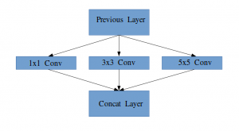Figure 4.5 A simple Inception architecture

**Types of DenseNet Models:**

1. **DenseNet-121**  
   This is the smallest version with 121 layers. It has about 8 million parameters.
2. **DenseNet-169**  
   This is a larger version with 169 layers and about 14 million parameters.
3. **DenseNet-201**  
   This is an even larger version with 201 layers and about 20 million parameters.
4. **DenseNet-264**  
   This is the largest version with 264 layers and about 33 million parameters.

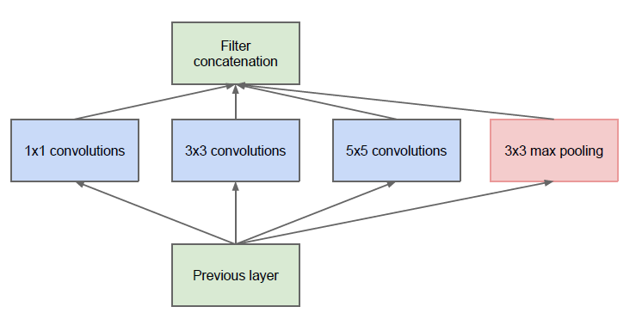 Figure 4.6 Inception V3 architecture

One of the key benefits of Inception-v3 is its ability to capture features at multiple scales and resolutions, which can lead to improved accuracy and reduced overfitting compared to other neural network architectures. Inception-v3 has been shown to be effective for image classification tasks, and has also been applied successfully to medical imaging tasks such as diagnosing Alzheimer's disease from MRI scans of the brain.

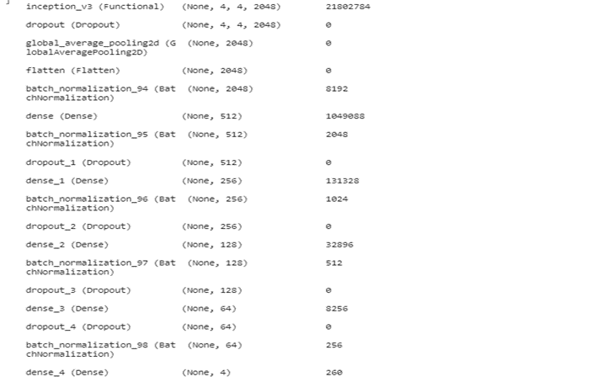

Figure 4.7 Inception Model Summary

1. **RESULTS AND ANALYSIS**

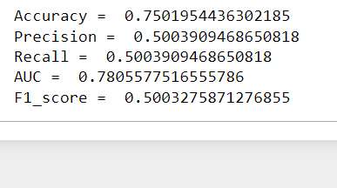 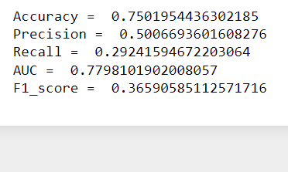

CNN

RNN

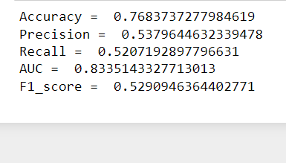 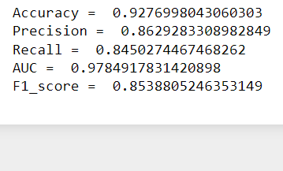

DenseNet-121

Inception-v3

Figure 5.1 Results

Below is the tabular comparison our results obtained by various models:

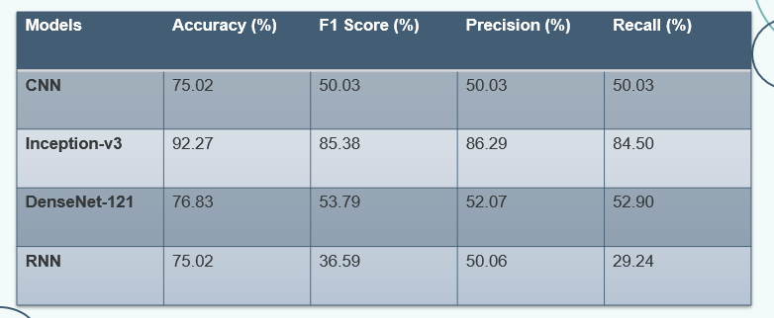

Figure 5.2 Results in tabular form

Our observation has shown that accuracy can be improved by using Inception-v3 model and by using DenseNet-121 as compared to typical CNN and SVM. Introducing regularization technique has also worked in improving the accuracy of the model. Out of them all , Inception-v3 model has best performed with accuracy of 92.27%.

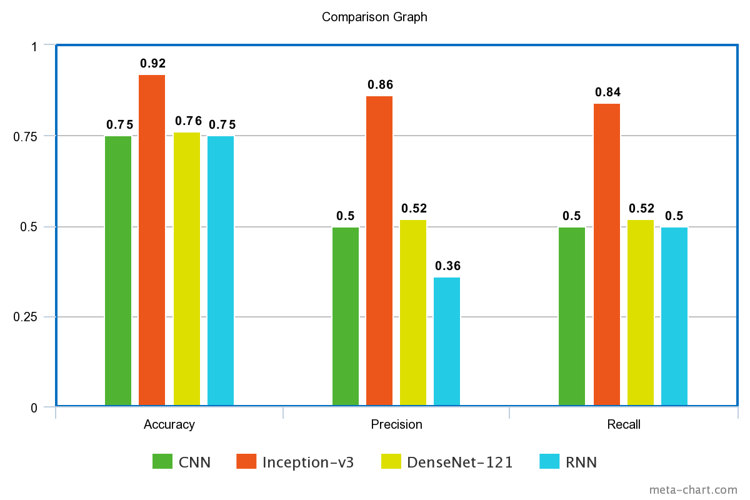

Figure 5.3 Graph Comparison of various models

SVMs are particularly useful when the number of features is relatively small compared to the number of samples and when the classes are well-separated.[3]

RNN works on sequential data where input data is a sequence.

1. **Deployment of model:**

We deployed the model and created a simple yet beautiful front-end where one can upload the MRI-Scan of the Brain and get the corresponding class category of the image. We used **Streamlit** build the user-interface.

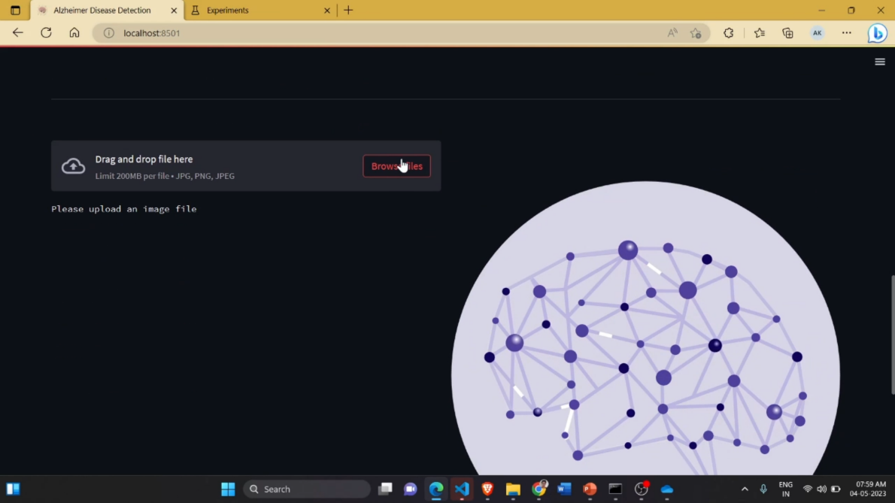

Fig.6.1: Interface for the model

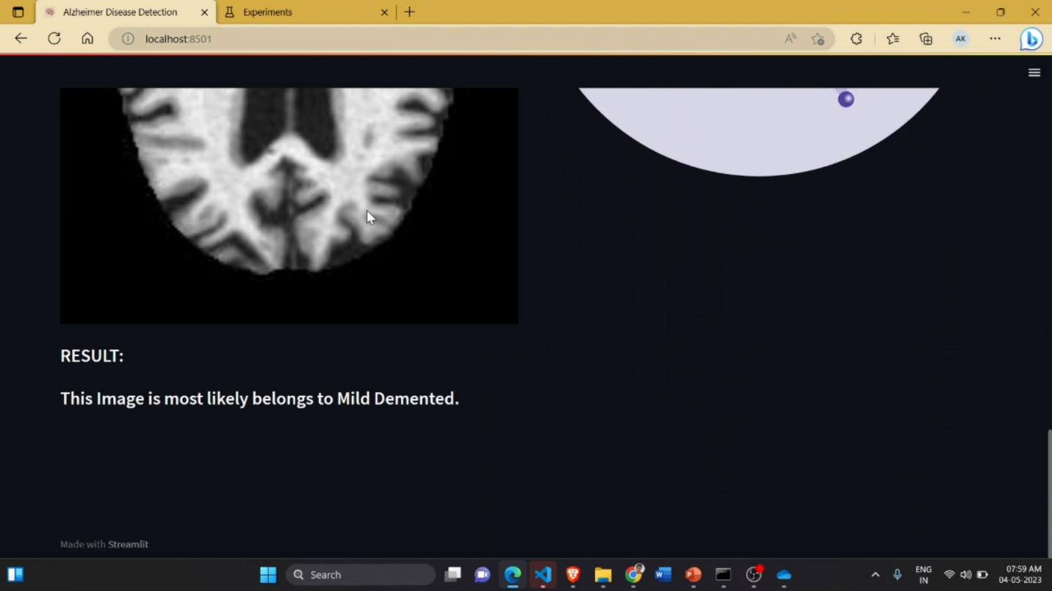

Fig.6.2: Result after the upload

1. **CONCLUSION AND FUTURE SCOPE**

A higher batch size can improve the accuracy, But due to the limitations of the machine and processing power the batch size could not be improved further.

In research paper “Towards Alzheimer’s Disease Classification through Transfer Learning by Marcia Hon and Naimul Mefraz Khan, Ryerson University ,Toronto, ON” the batch size of 40 and 100 epochs was found to optimal for achieving accuracy of 96% on testing dataset. Increasing the dataset will only make this model better.

A 3-D CNN is observed to perform better in case of MRI images classification.

In 3-D CNN slices of image that contain more information are extracted and then passed to the convolutional network.

This extraction is performed using auto-encoders and image entropy function.

The U.S. National Institute on Aging (NIA) is funding a 6-year, up to **$300 million** project to build a massive Alzheimer's research database that can track the health of Americans for decades and enable researchers to gain new insights on the brain-wasting disease.[4]

1. **References**

[1] S. Al-Shoukry, T. H. Rassem and N. M. Makbol, "Alzheimer’s Diseases Detection by Using Deep Learning Algorithms: A Mini-Review," in IEEE Access, vol. 8, pp. 77131-77141, 2020, doi: 10.1109/ACCESS.2020.2989396..

[2] Previtali F, Bertolazzi P, Felici G, Weitschek E. A novel method and software for automatically classifying Alzheimer's disease patients by magnetic resonance imaging analysis. Comput Methods Programs Biomed. 2017 May;143:89-95. doi: 10.1016/j.cmpb.2017.03.006. Epub 2017 Mar 4. PMID: 28391822.

[3] svmafa Kamal,A. Raghuvira Pratap,Mohd Naved,Abu Sarwar Zamani,P. Nancy,Mahyudin Ritonga,Surendra Kumar Shukla,and F. Sammy(2022), “Machine Learning and Image Processing Enabled Evolutionary Framework for Brain MRI Analysis for Alzheimer’s Disease Detection”

[4] Exclusive: US to build $300 million database to fuel Alzheimer's research https://www.reuters.com/business/healthcare-pharmaceuticals/us-build-300-mln-database-fuel-alzheimers-research-2023-04-03/